Hoplite Competition- 2022
(Grades K-8)

Rules and Overview
Objective of the Hoplite Competition

- To challenge a team of students to build a functional trebuchet (pronounced “TREB-YOO-SHAY” or “TREB-YOO-SHET”) from a provided kit.
- This Trebuchet must be able to safely launch a small rubber ball¹ in a manner that will accurately hit a target set anywhere between 2-10 feet away².
- To inspire and invigorate the true nature of the Engineering spirit!

Team Registration Rules
- All teams must have at least two members in grades K-5 or 6-8 and must have at least one adult sponsor who remains with the team during the entire competition. Elementary and middle school teams will compete separately.
- Schools may register more than one team.
Teachers/Mentors Directions for Registration No registration fee is required!
  - Complete the Group Registration Form.
  - Administer and collect each participant's Individual Registration Form.
  - Administer the electronic pre-survey of the selected competition.
  - Mail or Deliver entire packet to
STEM Center of Excellence at the Citadel
Attn: Jennifer Albert
171 Moultrie Street
Bond Hall, Room 340
Charleston, SC 29409
Participants:
    - Complete the Individual Registration Form.
    - Submit completed Individual Registration Form to the Teacher or Mentor sponsoring the team.
    - Complete pre-survey of the selected competition.
    - Upon receipt of your team’s full registration packet, your teacher/mentor will receive an email confirming your participation. If you have any questions about registration or the rules regarding the competitions, please contact Ashley Andrews at ashley.andrews@citadel.edu or 843-953- 7121.

- All rubber balls will be supplied by The Citadel, and will be identical in size and weight with no team having an advantage over another.
- Teams will not know the exact distance from which the trebuchets will be launched before the date of the competition.
That would ruin the fun and the fundamental aspect of the competition; which is to be able to know how much counterweight is required propel a rubber ball a certain distance. Testing the trebuchet before the competition is very important.

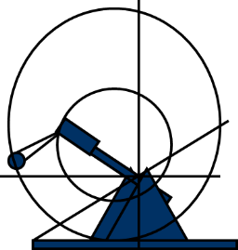
Funding

Storm the Citadel!
TREBUCHET COMPETITION 2022
If funding is available, Lowcountry K-12 schools that require funding to support the construction of a team trebuchet and participation in this event will complete a Memorandum of Understanding (MOU). This information will be made available in January 2022 and is dependent upon remaining funds.
The MOU requires each school to:
- Lead a team of two or more students in the development of a trebuchet in order to compete in the Storm The Citadel 2022 Trebuchet Contest on February 12, 2022.
- Attend, along with their team of students, and compete in the “Storm The Citadel” 2022 Trebuchet Contest on February 12, 2022.
- Return registration, release forms and pre-surveys on time (by January 14, 2022).
- Maintain timely communications via email and phone with STEM Center staff.
- Utilize funds only for trebuchet materials, transportation to and from the event, and other items in to support the team’s participation in the trebuchet competition.
- ORIGINAL RECEIPTS ARE REQUIRED!

Contact Jennifer Albert for more information: jalbert@citadel.edu or 843-953-7121

Please read carefully the Safety and Design specifications when designing and constructing your trebuchet. The regulations are there for your benefit. If you arrive at competition with a trebuchet that does not meet specifications, you will be disqualified from competition (and we want everyone to be able to compete!). Every trebuchet will be inspected prior to competition.

Competition Schedule
Date of Competition is set for Saturday, February 12, 2022
at The Citadel McAlister Field House.
  - All schools will be notified immediately in case of any changes.
  - Sign-in for the competition begins at 8:00am in front of McAlister Field House on the parade grounds of The Citadel. Registration consists of a formal sign-in of all team members with inspection/qualification following shortly thereafter.
  - The inspection/qualification process will consist of:
    - A basic construction inspection ensuring that the trebuchet is safe to operate and meets trebuchet guidelines (see below).
    - Submittal of your Trebuchet Poster Board (see below).
    - An operational test demonstrating that the trebuchet can launch a small rubber ball at least 6 feet.
  - Competition Schedule is attached.
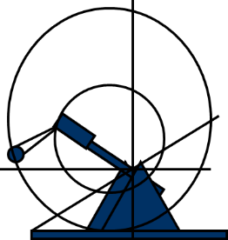

Storm the Citadel!
TREBUCHET COMPETITION 2022

Trebuchet Construction Rules
- Materials: The trebuchet must be built using most of the original parts in your kit. It is highly recommended that the trebuchet be built as close to the instructions as possible. It is understood that accidents can happen and parts may need to be replaced, but every effort should be made to keep as close to the original parts as possible. Additional materials may be added to the trebuchet (paint, wheels, stickers, etc) for design; keep in mind that extra décor may affect your trebuchet’s performance! Additional support materials such as nails, screws, brackets etc. may be used as well. A teacher or other adult supervisor must be present during the construction of the trebuchet.

- Counter-Weight: It is recommended that teams use counterweights that are easily adjustable: pennies, marbles, or other such small and heavy items in order to make it easier to adjust the distance of the trebuchet.

- Physical Integrity: All parts of the trebuchet must be secure, and all trebuchet parts must stay securely attached to the trebuchet during the competition (especially during launch!). Other aspects of integrity include:

  - The base must not have excessive wobble during launch. Wheels are acceptable on the base but must be securely attached and not pose any obvious safety concern.
  - If using a platform, it must be attached and cannot exceed 4 inches.
  - Extra weight is allowed to be placed on the base to increase stability.
  - Significant cracks, loose parts, obvious deformations, and any other observed problems with trebuchet must be corrected prior to competition or run the risk of disqualification.

- Safety/Conformance: All aspects of these safety regulations will be strictly enforced:
  - No modification to the trebuchet to make a catapult or catapult/hybrid, or any other form of weapon/ballistic launcher is allowed.
  - No energy other than the gravitational potential energy of the counterweight can be used to power the trebuchet. No springs, electrical devices, elastic material, flexible arms, or deformed components, which store energy, can be used.
  - No other ballistics other than those supplied by The Citadel may be used during qualification, practice, and competition.
  - Trebuchet Qualification Checklist must be completed prior to registration.

*Safety goggles will be provided for team members within the designated trebuchet launch area.

The Trebuchet Kit

Storm the Citadel!
TREBUCHET COMPETITION 2022
Your trebuchet kit will arrive in pieces. There will be no cutting or sawing necessary to build the trebuchet, just some glue and several hours of patience. No pre-built trebuchets will be available.
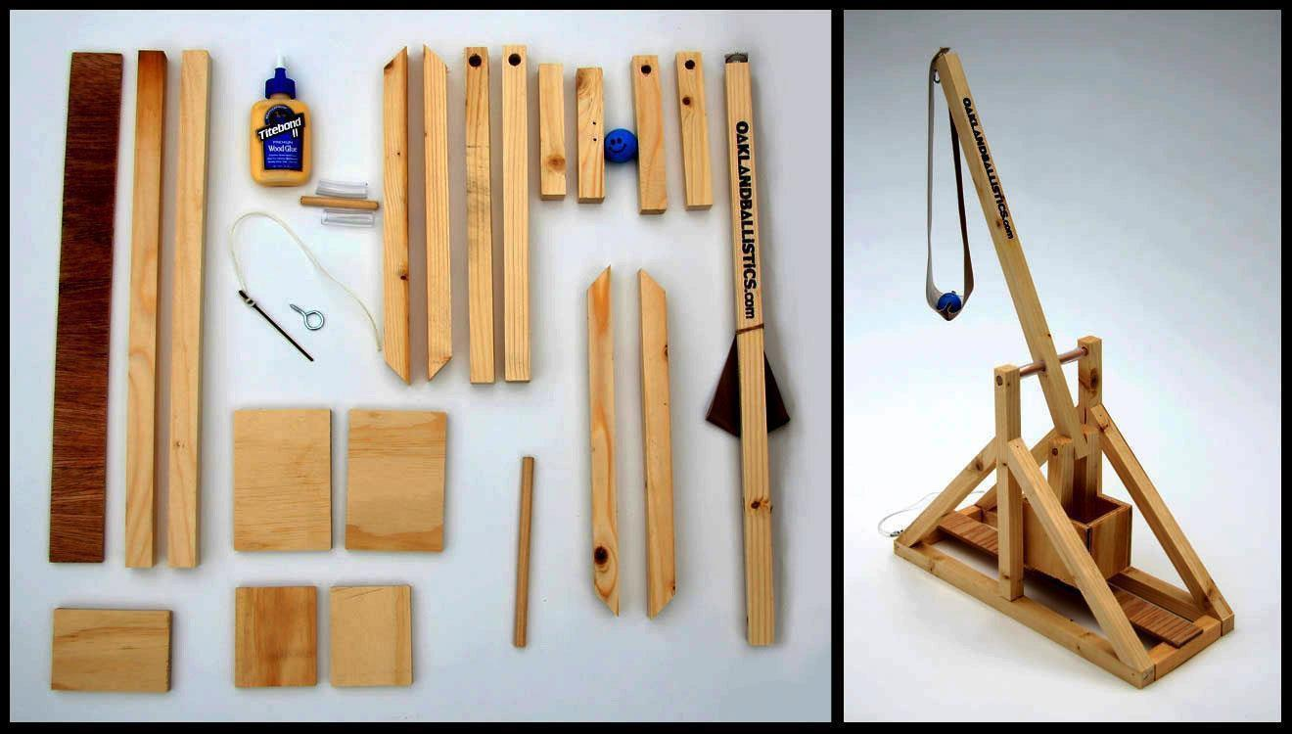

Image: Trebuchet Kit and completed trebuchet

The kit will come with everything needed to construct a functional trebuchet. This year we will be purchasing kits from a new supplier and will have more details in late fall. We recommend keeping all parts and materials together as you build the trebuchet so parts are not lost. Also, set aside time to allow glue to dry on parts so they set correctly. Take the time to sand the edges of the parts as well. A well- built trebuchet will perform better than one that wasn’t!

Testing
Make sure you test the trebuchet prior to the competition, do not wait until the last minute to build your trebuchet either. Testing takes time, you should know how the trebuchet performs with different weights, and investigate how it holds up after repeated launches. Teams are encouraged to use their graphs to guide them during the accuracy competition.

- Most Accurate
Awards

Storm the Citadel
TREBUCHET COMPETITION 2022
First, second, and third place trophies will be issued to the teams who have the highest combined score based on their proximity to a target. Each team will have three launches during the formal competition stage for this part of the competition, and the sum of the scores of the three launches will be the final score. (Please see competition rules for more information).
Earn extra points by entering the Poster Board Contest! See Details below!

- Spirit Award

These trophies will be issued to the teams that show excellence in any combination of the following criteria: Trebuchet décor, costumes/apparel, historical detail, cheers, and overall “Team Spirit” (Please be respectful and mindful of other teams and to the spirit of the competition)¹.
To be eligible for the Spirit Award, Trebuchet must pass safety and operational inspections.

- Trebuchet Poster Board Award

It is good practice to write down thoughts, ideas, and discoveries as your team builds and tests its trebuchet. Poster Boards will be judged on the day of the competition. Students should be prepared to be interviewed by judges. Requirements for the tri-fold poster board are as follows (see pg. 11 for more details):

Criteria | Description
Names | Team Name & Members Present
Timeline | Construction Timeline
Design | Photos of Team Construction & Testing
Graphs/Data | Graph of Test Trial Results
Summary | Summary of Lessons Learned; problems encountered; solutions to problems.

- Trebuchet Video Award

Tell us your story! Create a 1-2 minute video documenting the story behind building and testing your trebuchet. See pg. 12 for criteria and rubric.

All prizes and trophies will be appropriately awarded to the team as a whole, not the individuals of a team.

Competition Procedure

Storm the Citadel!
TREBUCHET COMPETITION 2022

- Qualification
All Hoplite Teams will register at McAlister field house. After registration on the day of the event, each team is required to complete qualification for competition. Steps for qualification include:
  - Submittal of Prequalification Checklist (form provided)
  - Safety and Compliance inspection by judges
  - Qualification Testing: Each team must demonstrate that their trebuchet can launch a ball at least 6 feet safely
  - A team that does not pass the safety/compliance inspections or does not pass the qualification test will be given a sufficient amount of time to make required repairs and/or modifications. If a team fails any qualification or inspection a second time, they will not be allowed to compete. It is highly recommended that each team allow enough time prior to the competition date to ensure that their trebuchet operates safely and consistently.

- Accuracy Competition
  - Each team will be given a minimum of 10 minutes and 5 practice shots to test the operability of their trebuchet within the qualification area, markers will be designated within the qualification area for the minimum distance (6 feet) as well as target distance.
  - Designated launch areas will be set up for each launch site. When teams are called to the launch area, they must set up their trebuchet in their assigned launch area and be ready to compete.
  - Teams will be designated to a launch area based on a random drawing. No launch area will have any advantage over another; all launch areas will be the same distance away from the center of the target.
  - Each team will be given 3 projectiles for the official competition.
  - After each team is ready, a judge will issue the order to begin launching.
  - Each team in succession will launch one projectile after they are given a signal. After each team had a chance to fire a projectile, that team will have a maximum of 3 minutes to launch their next projectile. If a team is not ready to launch within the 3-minute timeframe, they will be disqualified from competition.
o Exception: Each team will have the ability to use a “time-out”. This time out can only be used once. Competition for other teams will continue during this time-out period, and no projectiles may be fired from the team that is using their time out. If all teams have fired all 3 of their projectiles during this time out period- and the time-out team is still not ready, they will be disqualified after 5 minutes.
  - Points will be given for proximity to the center of the target; a closer proximity yields a higher score. To receive the maximum 3 points, the ball must land inside Zone 3 bucket (see diagram). Care will be taken by our judges to ensure that the score is based on where the projectile hit first- not to where it eventually bounced or rolled. The sum total of the score will be their total accuracy score. All decisions of the judges are final. The target is designed and constructed such that it will be relatively easy to determine accuracy. Please note that the target zones are spread out in relative areas and that even a few inches can make a world of difference!

2. Accuracy Competition (continued)

Storm the Citadel!
TREBUCHET COMPETITION 2022

  - Only students will be allowed to operate the trebuchet. Mentors/parents may give encouragement, advice or direction, but will not be permitted to touch the trebuchet.
  - Any team that intentionally fires out of turn will be disqualified.
  - No persons other than the judges will be allowed to walk in the firing range during the launching.
  - It is the responsibility of each team to take great care that no person or property comes to harm due to the action of their trebuchet or their negligence.
  - A point of ‘zero’ will be given for a particular team’s turn if:
    - A team member is not wearing their safety glasses within the designated launch area.
    - A team launches their trebuchet prematurely (unintentionally).
    - Their projectile does not land within the outer perimeter of the target.

**Safety goggles will be provided for team members within the designated trebuchet launch area.
No Black-soled shoes are allowed on the court in McAlister Field House!

Competition Area

2-10 feet
Launch Area (Green circle represents
one launch area)
Target

Trebuchet Target Layout (above view)
Trebuchet Target Layout (above view)

Zone 1: 3 feet across

Zone 2: 2 feet across

Zone 3: 1 foot across

Zone 1
Zone 2
Zone 3

Trebuchet Target Layout (side view)
Trebuchet Target Layout (side view)

Zone 1 Height: 6 inches

Zone 2 Height: 12 inches

Zone 3 Height: 24 inches

*Drawings are not to scale

Zone 3
Zone 2
Zone 1

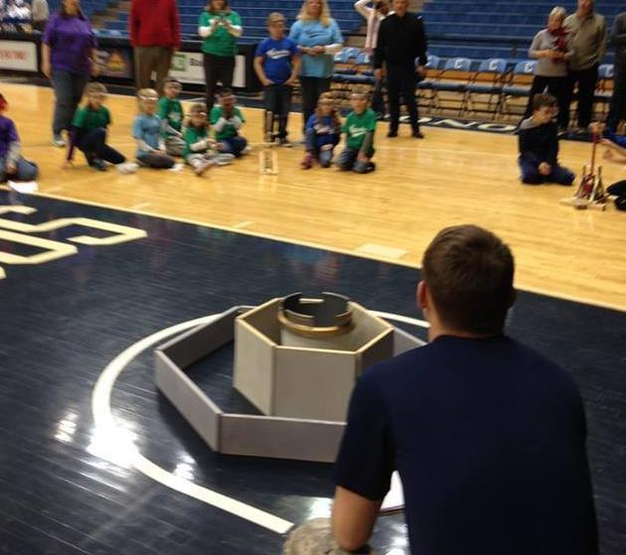
Scoring
Any ball that lands outside of the target area will be issued 0 points
Zone 1 (inside the first area) yields 1 point
Zone 2 (inside the second area) yields 2 points
Zone 3 (inside the center bucket) yields 3 points

Trebuchet Competition Schedule
(subject to change)

Time | Event
7:00 | - Barbarian Division Registration and Drop-Off Period Starts
8:00 | - Hoplite Division Registration Begins  - Centurion Middle School Division Registration and Drop-Off Period Starts
8:30 | - Centurion High School Division Registration and Drop-Off Period Starts  - Centurion Qualifications Begin
9:00 | - Centurion College, Military, and Corporate Division Registration and Drop-Off Period Begins
9:15 | - Hoplite Competition Begins  - Centurion Middle School Division Registration Ends
9:30 | - Centurion Middle School Division Competition Begins
10:00 | - Centurion High School Division Registration Ends
10:30 | - Centurion College, Military and Corporate Registration Ends
11:00 | - Hoplite Division Awards Announcement and Presentation
11:00 | - Centurion High School Division Competition Begins
12:00 | - Lunch available
12:15 | - Centurion College, Military and Corporate Division Competition Begins
1:30 | - Barbarian Division Competition Begins
2:45 | - Awards Ceremony For Centurion and Barbarian Division

Prequalification Checklist – Hoplite Division

Team Name:

School/Organization Name:

(Must be completed by team representative and must be supplied upon check in on the day of the competition)

 | Team Check | Judge Check  (At Competition)
Safety and Construction
The trebuchet is built using “most” of the original parts of the kit
Any part that has been changed or altered has been accounted for
The Trebuchet is only powered by the gravitational potential
energy of the counterweight, no other additional device to provide energy has been installed
The base is solid and does not have excessive wobble during launch
If wheels are installed on the base, they are safe and pose no risk
There are no significant cracks, loose parts, or obvious deformations
Competition Readiness
The trebuchet is fully built and tested; the team is
knowledgeable of proper set-up and operation
The team has tested the trebuchet with rubber balls successfully- with the ability to hurl a ball at least 10 feet
The team has reviewed all rules for competition, and is aware of the distance to the center of the target
Our team is ready to compete!

STC22 Hoplite Poster Board Award

Criteria:
- Team name, Team mentor and Team members
- Construction timeline
- Pictures of the construction and testing of the trebuchet.
- Problems
  - Did you have any problems building your trebuchet? Why?
  - Did anything break on your trebuchet? How did it break and how did you fix it?

- Testing & Data
  - How did you test your trebuchet? Be specific!
  - Include a graph of how far each ball flies vs. trebuchet counterweight mass (this will definitely help you out in the competition!)

- Solutions & Conclusions
  - All changes and modifications you made to the trebuchet and the reasons why; this includes any decorations!
  - What did you learn?

Each team can include more information but you should detail the information as if you were an engineer or scientist. Be specific! The poster board should be well organized, easy to read, and creative. Students should be prepared for interviews!
Trebuchet Poster Boards must be submitted at Registration on event day to be considered for the extra points.

Criteria:

STC22 Hoplite Video Award

- Team name, Team mentor and Team members
- Construction timeline
- Video of the construction and testing of the trebuchet.
- Problems
  - Did you have any problems building your trebuchet? Why?
  - How did you fix it?

- Solutions & Conclusions
  - All changes and modifications you made to the trebuchet and the reasons why; this includes any decorations!
  - What did you learn?

Rubric:
 | 4 | 3 | 2 | 1 | Total
Purpose and | Clearly relates | Relates to the | Some relation | Does not relate
Content | to the learning | learning | to the learning | to the learning
 | objective or | objective or | objective or | objective or
 | illustrates the | illustrates the | story. | does not
 | team’s | team’s |  | illustrates the
 | trebuchet | trebuchet |  | team’s
 | journey. | journey. |  | trebuchet
 |  |  |  | journey.
Titles, Transitions, and Effects | Titles and/or transitions enhance the video. | Titles and/or transitions do not detract from the video. | Attempts to use titles and/or transitions, but  they detract from the video. | No titles or transitions exist.
Video / Photos | Video and Photos relate to the subject. | Videos and photos mostly  relate to the subject | Videos and photos are few  and some are off topic. | No videos or photos relate to the subject.
Audio | Movie includes | Movie includes | Movie has only | Movie has no
 | voice and | voice and | music. Audio | sound.
 | music. Audio | music. Audio | levels are too
 | levels are just right. | levels are too low or too loud. | low or too loud.

